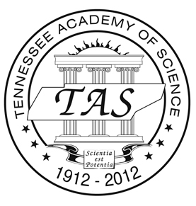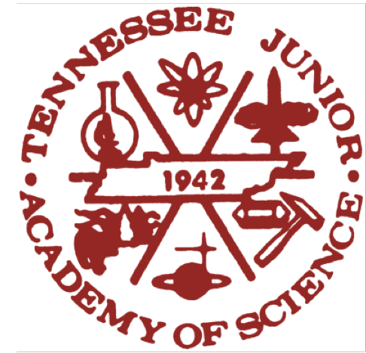

April 7, 2019

Greenfield High School
319 West Main St.
Greenfield, TN 38230

Dear Andrew Campbell Joshua Floyd, and Logan Rash,

Congratulations! Your paper was selected for presentation at the TJAS annual meeting during which we will celebrate the Academy’s 77th anniversary! On behalf of the Tennessee Academy of Science, I wish to extend an invitation for you to present your paper at the annual meeting of the Tennessee Junior Academy of Science on Friday, April 26, 2019. The meeting will be held on the campus of Belmont University in Nashville. Directions to Belmont are copied below. Please park in the garage beneath the Ayers Academic Center (#8 on the map at the following link, http://campus.belmont.edu/mp3/bu-parking-map_lr.pdf). For those of you who participated in the 2018 competition, this is the same building as last year’s meeting.
Directions: Exit I-65 at exit 81 and go west on Wedgewood Avenue for 0.8 miles. Proceed to the 15th Ave. stop light and turn left. Enter the two roundabouts at the rear of the Ayers Academic Center (AAC), turn right into the Ayers Garage and park in Visitors Parking on P1 (if full, go to lower levels P3 or P4). The TJAS will be held in the Ayers Academic Center’s 4th Floor Conference Center. This Conference Center is accessible only through the North Elevators of the Ayers Center. I would suggest that you arrive early in order to find the room on time.
Abstracts of all papers will be published in the annual Handbook and Proceedings of the Tennessee Junior Academy of Science, and the top two papers plus six other winning papers will be published in the Handbook. A $500 cash award will be presented to each of the top two winners, who are then eligible to represent Tennessee at the next meeting of the American Junior Academy of Science, which will be part of the 2020 meeting of the American Association for the Advancement of Science in Seattle, Washington. This meeting is always a very memorable experience for delegates, and the Academy will cover up to $1,000 of trip expenses. A $200 cash award will be presented to each of the other top six winners, who are also eligible to attend the AJAS meeting, with funding available if the winners do not attend. Judges will rate participants on the basis of research design and creativity, oral presentation, knowledge of the subject, and quality of the written paper. Oral presentations must be planned very carefully so as to be ten minutes in length. Please bring your PP slides on a USB flash drive; a computer and projector will be available. (You can load your PP on to the computer desktop as you arrive.)

Papers will be presented during two periods: 9:30-11:30 AM and 1:00-4:00 PM (Central time). Registration begins at 9:00 AM in the AAC Conference Room, Rm 4094. It is important that you arrive on time. Lunch will be served on campus.

Lunch will be provided in the Belmont cafeteria. Although we have attempted to allow the maximum travel time during daylight hours so that an overnight stay will not be required, presenters and teachers traveling from schools 150 miles or greater from Nashville will each be reimbursed up to $100 toward hotel accommodations (keep receipts).

If you will be able to attend the meeting, it is important that you complete the attached Release Form and return it to me no later than April 19, 2019, so that the program can be finalized and printed. If you have any questions, I can be contacted by e-mail at pmacdougall@mtsu.edu, phone at 615-898-5265, or fax at 615-898-5182, or cell phone 615-542-0470.

I am looking forward to hearing from you and seeing you in Nashville on April 26th.

Very Sincerely,

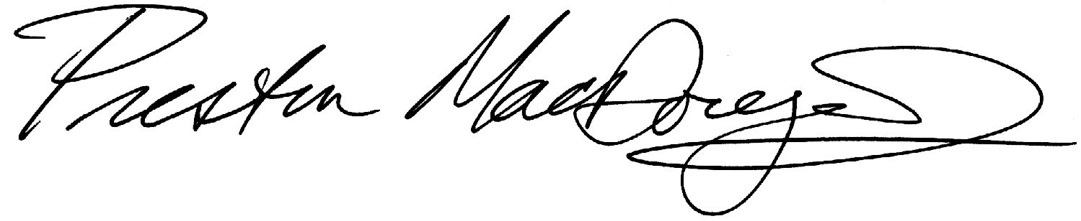
Preston MacDougall, Director
Tennessee Junior Academy of Science

cc: Mr. Robert McCall
Attachment: Release Form

